**SQL QUERIES**

**Answer the below questions in SQL using the data and schema:**

1. **What industries are Gen-Z most interested in pursuing careers in?**

SELECT `Aspirational Job`, COUNT(`Aspirational Job`) AS COUNT

FROM `career aspirations`

GROUP BY `Aspirational Job` ORDER BY COUNT DESC;

**Output:**

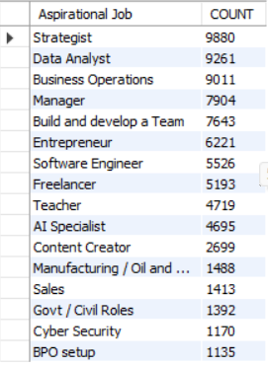

**Analysis:**

Gen-Z shows a strong preference for roles that involve strategic thinking and data analysis. The most popular choices include roles such as Strategist (9,880), Data Analyst (9,261), and Business Operations (9,011), reflecting their inclination toward decision-making, problem-solving, and analytical work. Managerial roles (7,904) and jobs focused on team development (7,643) also rank high, suggesting that many Gen-Z individuals aspire to take on leadership responsibilities early in their careers.

Entrepreneurship (6,221) and freelancing (5,193) are also prominent, indicating a desire for independence, flexibility, and creative freedom in their career paths. Technical roles like Software Engineer (5,526) and AI Specialist (4,695) are still attractive, but they are not the top choices, showing a slight shift away from purely technical functions toward more interdisciplinary roles.

On the other hand, careers in traditional sectors such as Manufacturing/Oil (1,488), Sales (1,413), Government roles (1,392), Cybersecurity (1,170), and BPO setups (1,135) are the least favored. This points to a clear generational shift away from conventional, structured jobs toward roles that offer innovation, creativity, flexibility, and personal growth.

1. **What are the top factors influencing Gen-Z’s career choices?**

SELECT `Influencing Factor`, COUNT(`Influencing Factor`) AS COUNT

FROM `career aspirations`

GROUP BY `Influencing Factor` ORDER BY COUNT DESC;

**Output:**

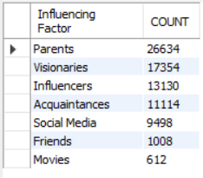

**Analysis:**

The data shows that parents are the most significant influence on Gen-Z’s career choices, with 26,634 mentions. This indicates that family opinions still play a major role in shaping their future decisions. Following that, visionaries (17,354) and influencers (13,130) have a strong impact, suggesting that Gen-Z is also inspired by thought leaders and social figures they admire.

Acquaintances (11,114) and social media (9,498) also play considerable roles, reflecting the generation's reliance on digital networks and extended social circles for information and guidance. Interestingly, friends (1,008) and movies (612) are much less influential, showing that personal peer groups and media portrayals may not significantly drive their career decisions.

Overall, Gen-Z appears to be guided by a blend of traditional family influence and modern-day mentors or public figures, with less emphasis on entertainment or casual social input.

1. **What is the desired work environment for Gen-Z? (e.g., remote, hybrid, in-office)**

SELECT `Preferred Working Environment`, COUNT (`Preferred Working Environment`) AS COUNT

FROM `career aspirations`

GROUP BY `Preferred Working Environment` ORDER BY COUNT DESC;

**Output:**

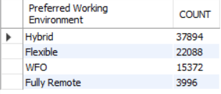

**Analysis:**

The most desired work environment for Gen-Z is clearly hybrid, with 37,894 respondents preferring a mix of remote and in-office work. This reflects their inclination toward a balanced lifestyle that allows both flexibility and in-person collaboration.

The second preference is flexible work setups (22,088), indicating a strong demand for autonomy over when and where they work. Traditional work from office (WFO) is less popular (15,372), and fully remote roles are the least preferred (3,996), suggesting that while Gen-Z appreciates flexibility, they still value some level of physical interaction and structured workspace.

1. **How do financial goals, such as salary and benefits, impact career aspirations among Gen-Z?**

SELECT

'Minimum salary early career' AS Salary_Stage,

`Minimum salary early career (monthy)` AS Salary_Range,

COUNT(*) AS Count

FROM `career aspirations`

GROUP BY `Minimum salary early career (monthy)`

UNION ALL

SELECT

'Salary for first 3 years' AS Salary_Stage,

`Salary For first 3 years` AS Salary_Range,

COUNT(*) AS Count

FROM `career aspirations`

GROUP BY `Salary For first 3 years`

UNION ALL

SELECT

'Salary after 5 years' AS Salary_Stage,

`Salary after 5 years` AS Salary_Range,

COUNT(*) AS Count

FROM `career aspirations`

GROUP BY `Salary after 5 years`;

**Output:**

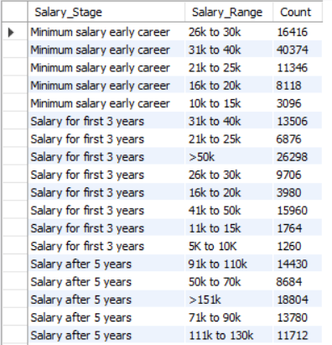

SELECT `Work life balance break`, COUNT(`Work life balance break`)

FROM `career aspirations`

GROUP BY `Work life balance break`

ORDER BY COUNT(`Work life balance break`);

**Output:**

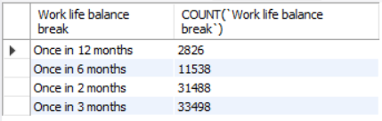

**Analysis:**

Gen-Z places a strong emphasis on financial growth throughout their careers. The majority expect a minimum early-career salary between ₹31k to ₹40k, and by the end of 3 years, over 26,000 respondents aim for salaries exceeding ₹50k. Expectations for 5-year salaries rise steeply, with more than 18,000 anticipating earnings above ₹1.5 lakhs per month. Additionally, work-life balance is a priority, with most preferring breaks every 2 to 3 months, showing that Gen-Z values both financial success and periodic rejuvenation for long-term career satisfaction.

1. **What role do personal values and social impact play in career choices for Gen-Z?**

SELECT `Work under abusing manager`, COUNT(`Work under abusing manager`)

FROM `career aspirations` GROUP BY `Work under abusing manager`;

**Output:**



SELECT `Work for company bringing no social impact`, COUNT(`Work for company bringing no social impact`)

FROM `career aspirations` GROUP BY `Work for company bringing no social impact` ORDER BY COUNT(`Work for company bringing no social impact`) DESC;

**Output:**



SELECT `Work for missionless company`, COUNT(`Work for missionless company`)

FROM `career aspirations` GROUP BY `Work for missionless company`;

**Output:**



SELECT `Work for misaligned mission Company`, COUNT(`Work for misaligned mission Company`)

FROM `career aspirations` GROUP BY `Work for misaligned mission Company`;

**Output:**

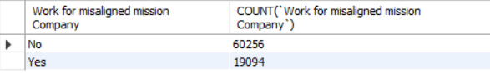

**Analysis:**

The overwhelming 81% who are not willing highlights that mental well-being, respect, and supportive leadership are non-negotiable for Gen-Z.

Gen-Z wants their job to have a clear purpose and broader social value, not just be a source of income.

Even if a company has a mission, if it conflicts with Gen-Z’s beliefs, it becomes a barrier to engagement.

Personal values and perceived social impact are not just preferences—they are core determinants of career decisions.